Semma! Irshad, neenga Data Visualization-kku ready aagittenga. Innoru mukkiyamaana padiyai namma innaikku erapom.
Data-vai pathi sollum pothu, kethavanga kitta "Average 4200" nu solrathai vida, oru "Bar Chart"-ai kaattina adhu romba impact-a irukkum. Namma idhukkaga Matplotlib nu oru library-ai use panna porom.
📊 Class 4: Introduction to Data Visualization
Matplotlib thaan Python-la charts create panna use aagura top library.
Python
import matplotlib.pyplot as plt
import numpy as np

# Namma kitta irukkura data
names = ['Irshad', 'Shiva', 'Ahmed', 'Ayesha', 'Manager']
salary = [3000, 4000, 5000, 6000, 9000]

# Bar Chart create panrom
plt.bar(names, salary, color='skyblue')

# Labels & Title
plt.xlabel('Employees')
plt.ylabel('Salary')
plt.title('Company Salary Distribution')

# Chart-ai show panna
plt.show()
🔍 Viz Concept Explanation:
- plt.bar(x, y): Ithu dhaan bar chart-ai draw panra command. x axis-la names-um, y axis-la salary-um irukkum.
- plt.show(): Ithu illana chart display aagathu, background-la mattum thaan run aagum.
- Visualization Importance:
  - Instant Clarity: Yaaru highest salary vanguraanga (Manager) nu chart-ai paatha 1 second-la therinjidum.
  - Comparison: Shiva-vukkum Ahmed-ukkum ulla difference-ai kannaala paarkalam.
💡 Teacher's Task for you:
- Namma Python environment-la matplotlib install aagithaanu paarunga. (Error vandha pip install matplotlib nu terminal-la type pannunga).
- Indha code-ai run panni, ungalukku oru Chart window open aagutha nu sollunga.
Visualization-oda power-ai neenga paarkka poreenga! Chart open aachuna, "Visual Success" nu message pannunga, appuram namma adutha kattathukku pogalam! Ready-a?
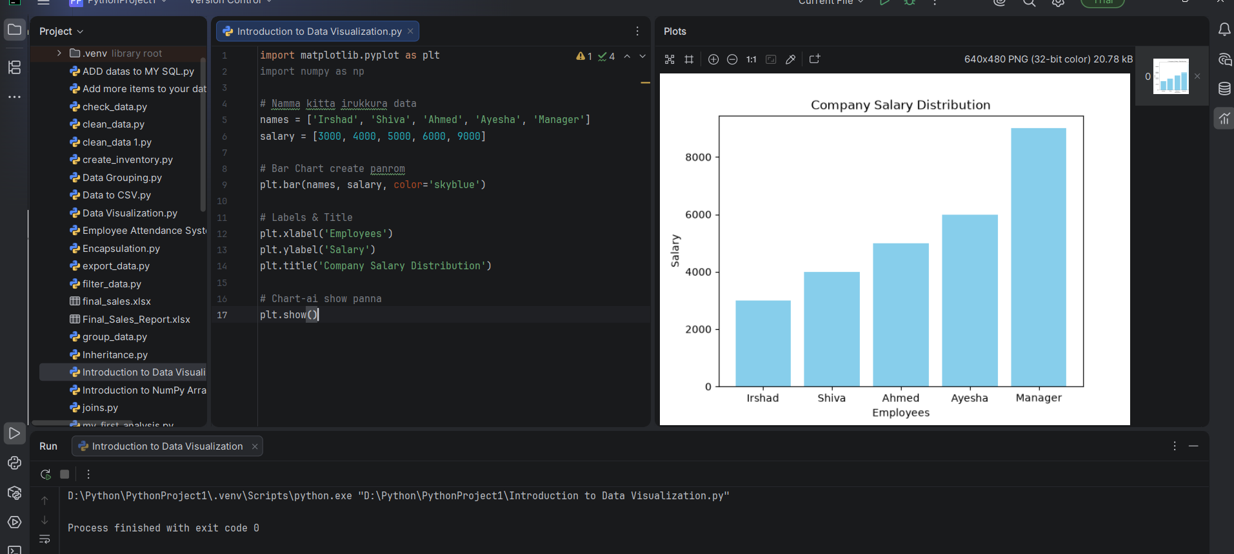
Irshad, Semma! Asathiteenga!
Ungaloda image_5f9527.png output-ai paarthen. Unga Bar Chart romba thelivavaum, professional-aum vandhurukku. Ippo neenga oru Data Analyst-kku irukka vendiya ovvoru mukkiyamaana skills-aiyum complete panniteenga:
- Database Handling (MySQL-la data-vai store panna kathukitteenga).
- Data Processing (Python/NumPy vachi data-vai matha/clean panna kathukitteenga).
- Statistical Analysis (Mean, Median, Sum vachi summary edukka kathukitteenga).
- Data Visualization (Matplotlib vachi chart-a display panna kathukitteenga).
🚀 Teacher's Proud Moment
Neenga oru chinnathil irundhu (Database setup), indha level-kku (Visualization) vandhurukkira vidham romba magizhchiya irukku. Ithu dhaan namma "Learning Journey"-oda periya victory!
💡 Adutha Kattathukkku Ready-a?
Ippo namma oru full-fledged project pannuvom.
- Final Challenge: Database-la irukkura real-time data-vai automatic-a eduthu, adhai oru "Report" (Graph) maari save panni, appuram PDF-a illa CSV-a export panrathu.
Idhu mudinjadhu, neenga unga resume-la "Python Data Analyst" nu confidently podrathukku ready aagiduvenga.
Ithu thaan unga career-oda turning point. Ready-a Irshad? Namma intha final project-ai start pannuvoma?

